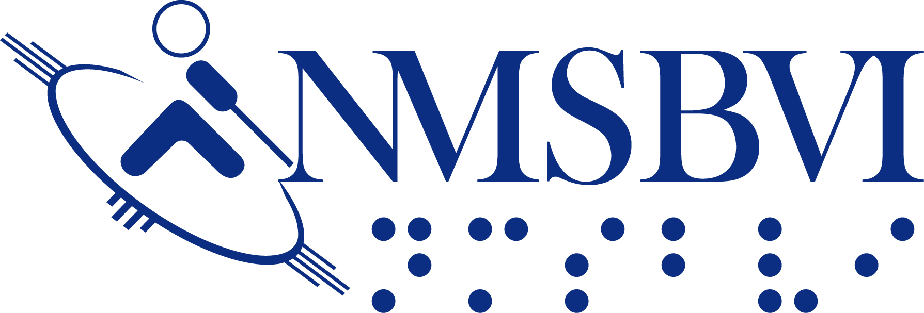
IRC ~ Equipment, Material & Supply Order Form
(Please use one form per student)

Please submit form via fax or email.
Please fill in this form electronically; then fax the printout to (575) 439-4498; or email it as an attachment to IRC@nmsbvi.k12.nm.us.
Questions? Please call IRC Specialist, Lisa Meisch, at 575-439-4437.

PLEASE MAKE COPIES OF THIS FORM AS NEEDED

Student Name: Date of Request:
School District: Requesting Teacher:
Street or Box No. Date Materials Needed:
City/Zip: FAX No.:

Quantity Catalog No. Page # Title or Description Price Total Status of Order
(NMSBVI USE ONLY)

IRC USE ONLY
Order Number
Date Received Name of Designated Contact Person:
(Revised February 2014)
Phone:

